**Tirthan Valley, Himachal Pradesh**

**The Tirthan valley** is the main gateway to the Great Himalayan National Park (GHNP). Actually, without the national park, the secluded valley would have probably remained unknown.

The name of the valley comes from the Tirthan River that flows from Tirth, its origins located in the GHNP, and ends at Larji in the Beas river.

The Tirthan valley has plenty of hidden gems and so, it will allow you to enjoy various activities such as relaxation, day hikes, multi day treks or trout angling.

Best time to visit Tirthan valley is **March, April, May, June**, and then **October, November and December**.  
  
Avoid the monsoon between July and August as it rains a lot and the paths become slippery and there are chances of landslides.

1st image:

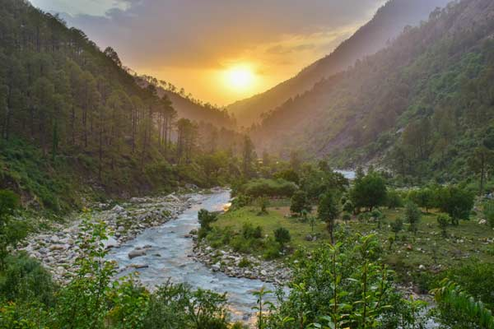

[**https://www.himalayanecotourism.com/pictures/tirthan-info/himalayan-ecotourism-tirthan-valley-07.jpg**](https://www.himalayanecotourism.com/pictures/tirthan-info/himalayan-ecotourism-tirthan-valley-07.jpg)

**2nd image:**

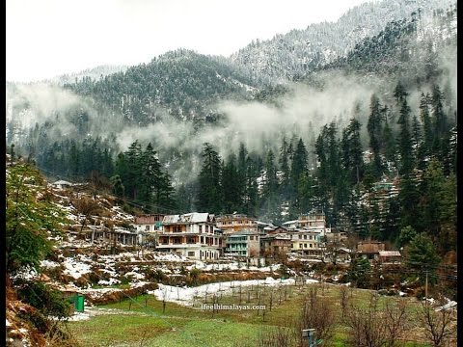

[**https://i.ytimg.com/vi/5sOtkR9Q-xU/hqdefault.jpg**](https://i.ytimg.com/vi/5sOtkR9Q-xU/hqdefault.jpg)